Complex Embedded System **:- WIFI ROUTER**

* A wireless router connects directly to a modem by a cable. This allows it to receive information from — and transmit information to — the internet. The router then creates and communicates through built-in antennas.

**Block Diagram :-**

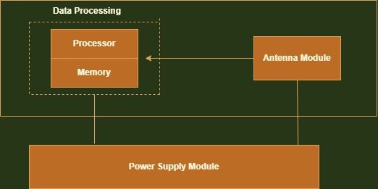

Components :-

* **WAN:** A wide area network (also known as WAN), is a large network of information that is not tied to a single location. WANs can facilitate communication, the sharing of information and much more between devices from around the world through a WAN provider.
* **LAN:** .A local area network (LAN) is a collection of devices connected together in one physical location, such as a building, office, or home. A LAN can be small or large, ranging from a home network with one user to an enterprise network with thousands of users and devices in an office or school.
* **Antenna**: 4 External Antennas
* **LED indicators:**
* **Buttons:** Reset. WPS**.**
* **Power Supply**: